Lecture Series 27.05.2021
Prof. Dr. Stijn Reijnders (University of Rotterdam) „Worlds of Imagination. Media, tourism, culture”
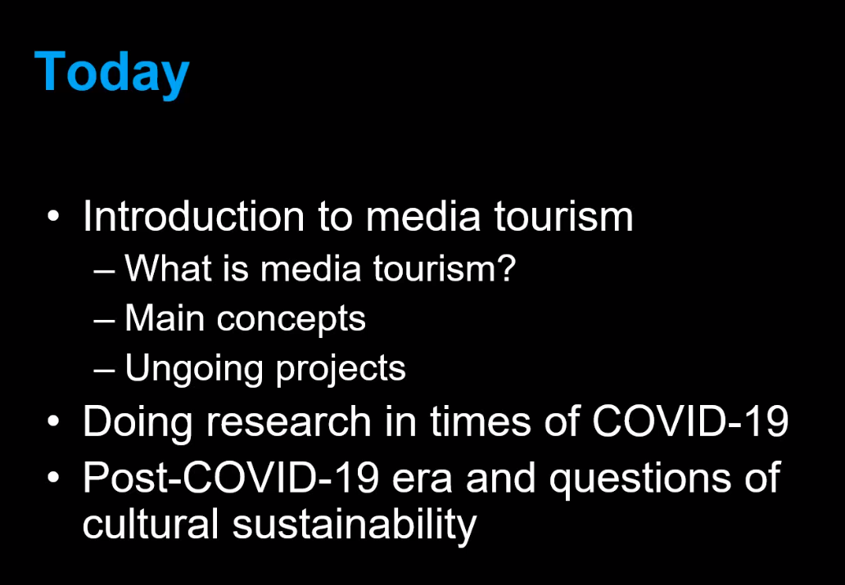

Media tourism != Screentourism

Screentourists in Exeter College and the death of a fictional character:
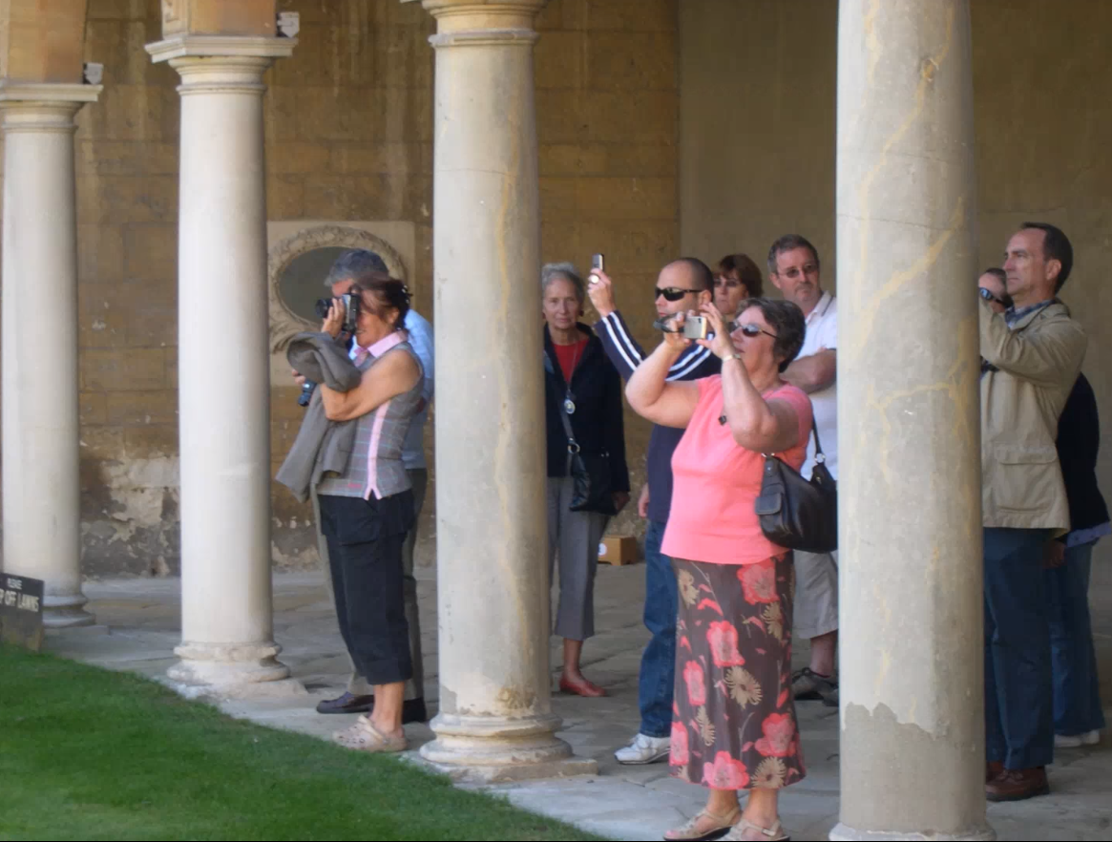
Detective tours are famous around Europe in first and secondary cities

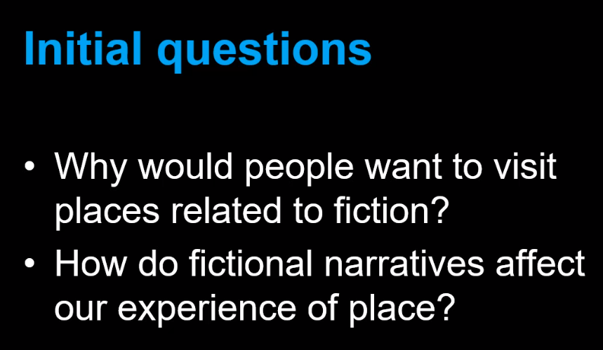
Media tourism is really old:
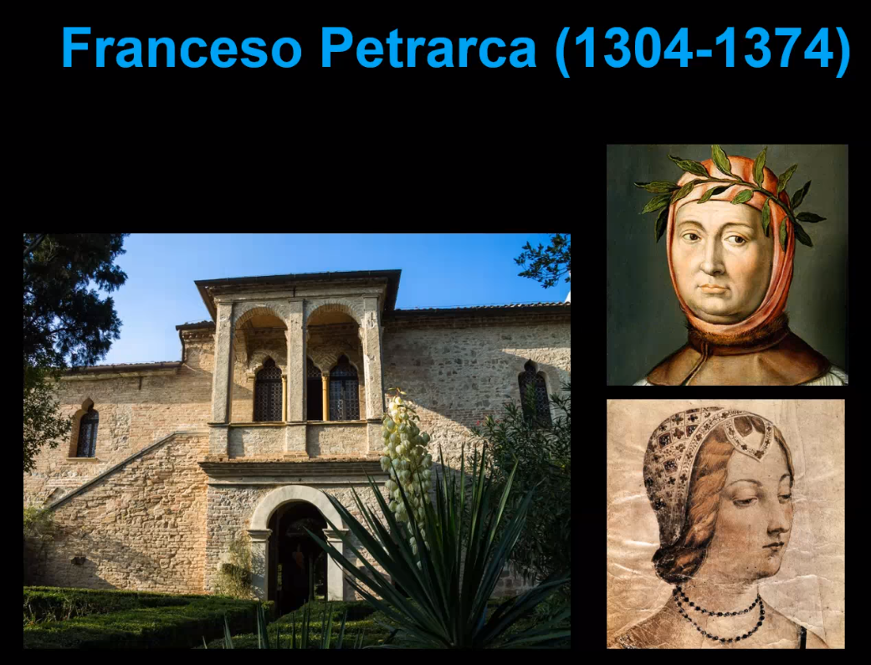

Examples:
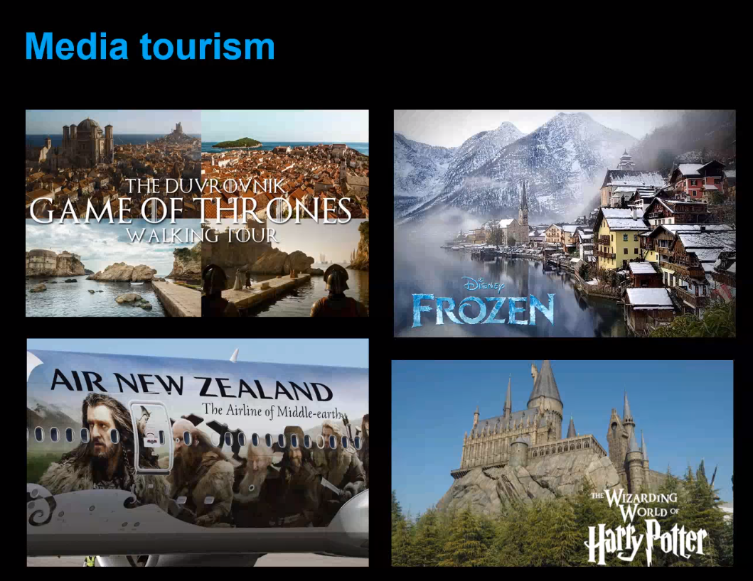

Film productions are working together with local municipalities and cooperate with city marketing.

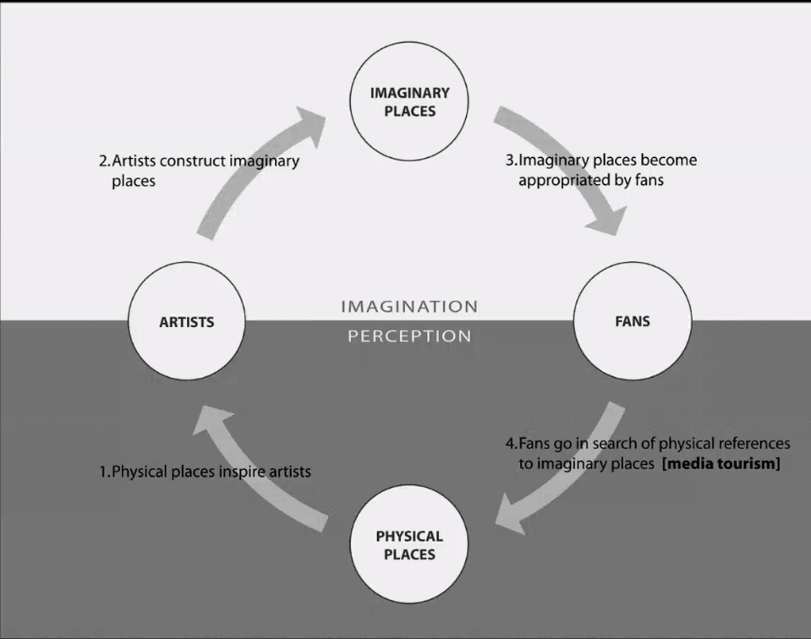

[Idee:] Levels of media related tourism
Media tourism
Screen tourism | Literature tourism | Music Tourism
Film tourism | TV tourism
On location | Off Location | Actor tourism | Studio tourism

“People have a need for places to anker their imagination, that’s why they search for these places”

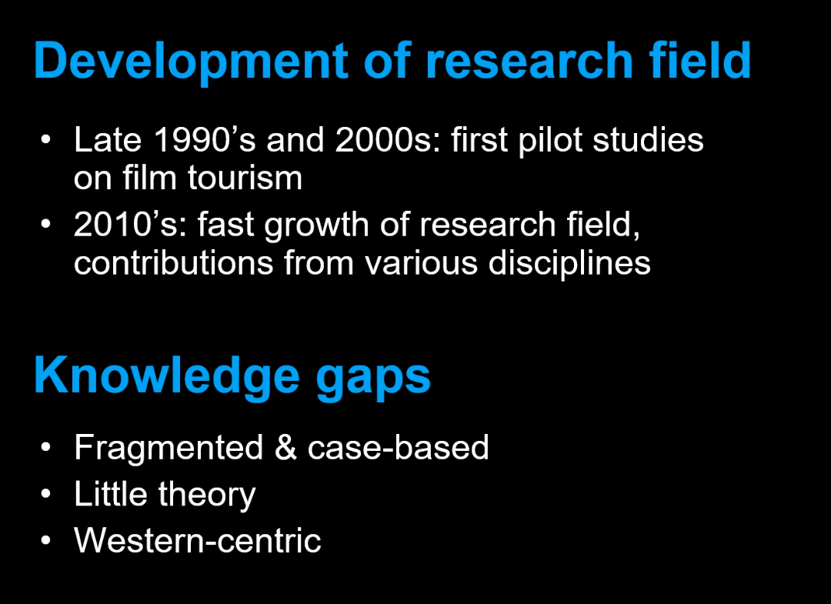

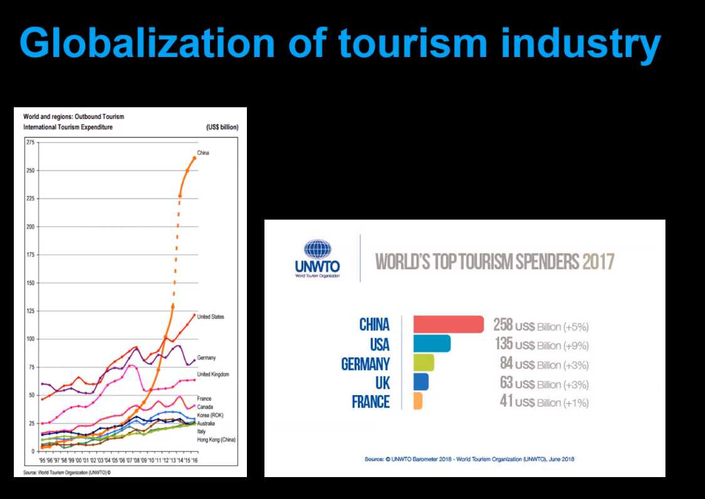

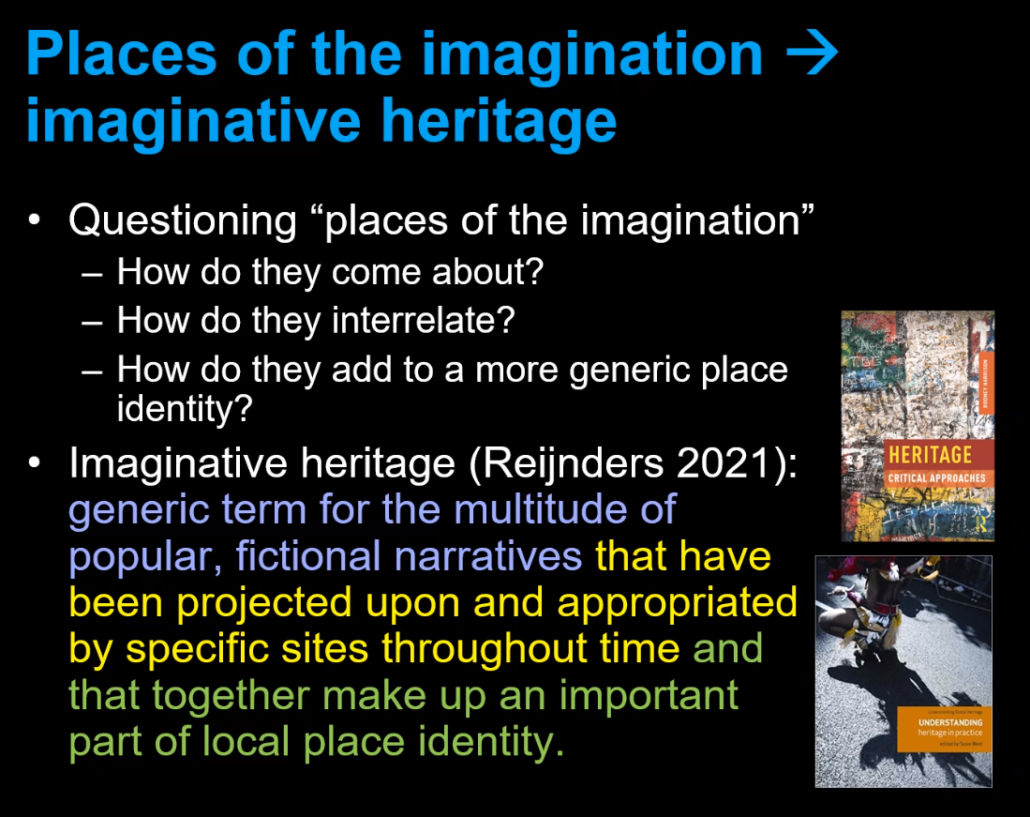
Imaginative Narratives can become part of the heritage

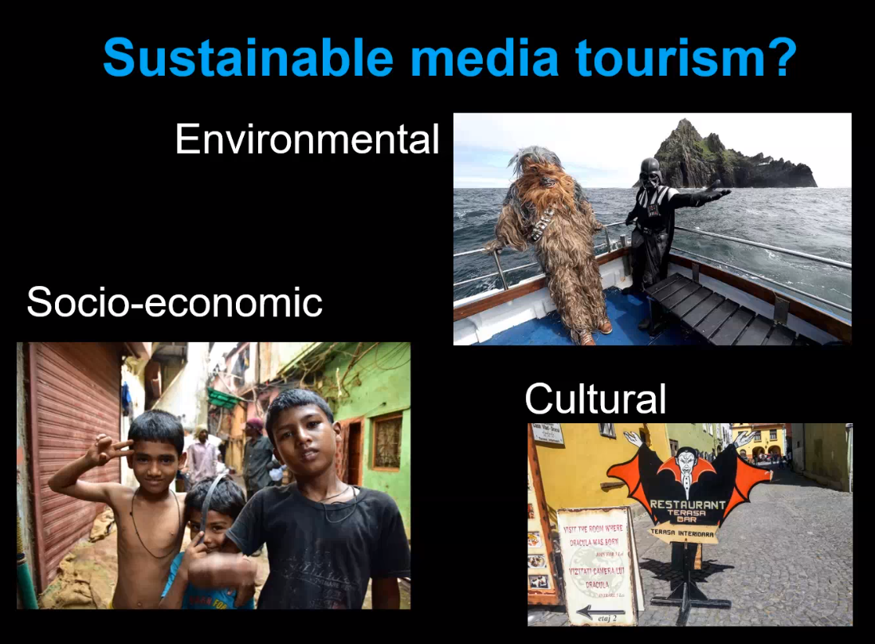
Media tourism gets a lot of criticism in all 3 fields of conflict
Environmental: Star Wars Tourism on an nature refuge
Socio-Economic: Slum Dog Millionär Slum Tours from rich tourists gazing at the poor locals
Cultural: Dracular tourism is overwriting with global popular culture the local heritage

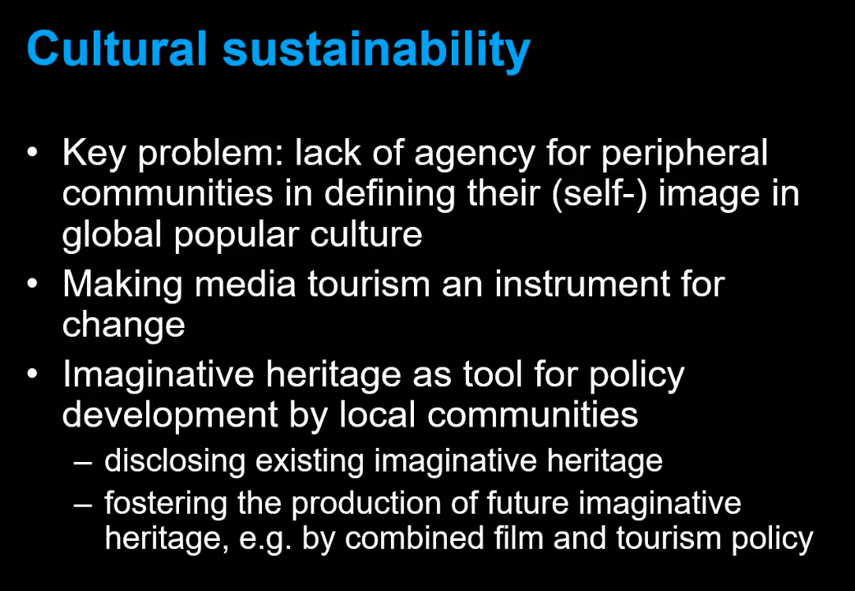

“You cant have cultural power without economic power and prosperity.”

“Fictional and historical narratives are closely related. History is a narrative about the past.”

His book: https://www.taylorfrancis.com/books/oa-edit/10.4324/9781003045359/locating-imagination-popular-culture-nicky-van-es-stijn-reijnders-leonieke-bolderman-abby-waysdorf

